3.2 instructions for File Hashing

Prerequisite

- Node js (16.11.1)
- xt-package-manager downloaded from github

3.2.1 Hashing of tar files
Here we use the crypto module to hash the tar file and the output hash is HEX code

A Configuring the path of the file

- Open xt-package-manager / verification / path.json

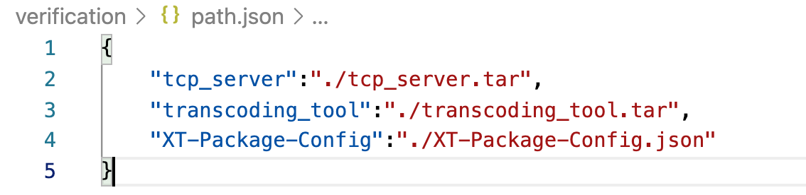

- Update the File path

B Hashing process

Installing dependencies

- Open Terminal at the root of the verification directory
- Run command npm install

To get hashes for files in the path.json

- Open Terminal at the root of the verification directory
- Run command node individualFileHash.js

Note the hash code for two files in the console which will be used to update in XT-Package-Config.json later

3.2.2 Updating XT-Package-Config.json

TCP-Server
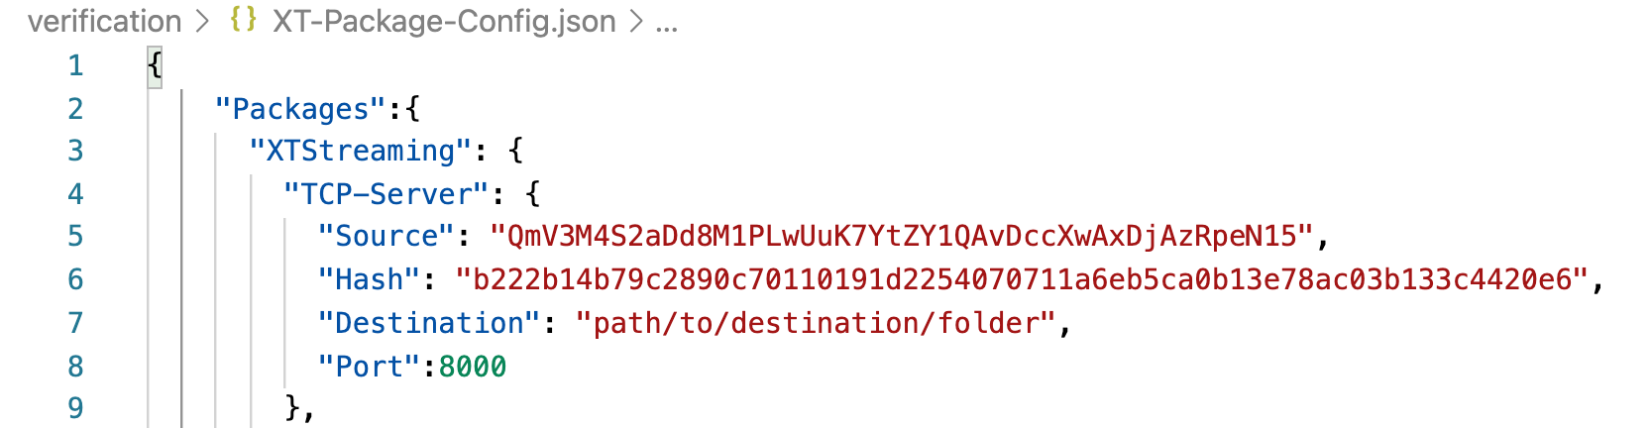
Source: CID value of tcp_server noted in step 3.1.2(A) Refer Document: 3.1-Creating tar files and updating tar files to the ipfs
Hash: Hash code created for tcp_server in previous step 3.2.1(B)
Destination: path where the xt-package-manager to copy the tar files
Port: port to which the tcp_server is listening.

Transcoding-Tool

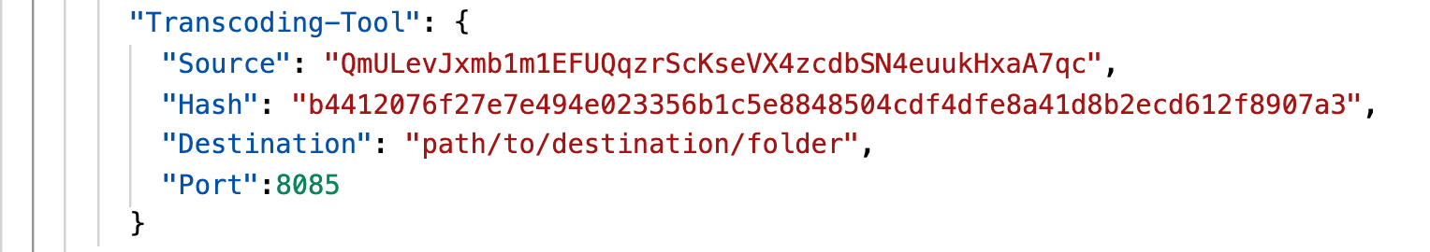

Source: CID value of Video_Transcoding_Tool noted in step 3.1.2 (B) (Refer Document: 3.1-Creating tar files and updating tar files to the ipfs )
Hash: Hash code created for transcoding_tool in previous step 3.2.1(B) ()
Destination: path where the xt-package-manager to copy the tar files
Port: port which the transcoding_tool is listening.

3.2.3 Hashing Packages content inside XT-Package-Config.json

- Open Terminal at root of verification directory
- Run command node node packageHashing.js

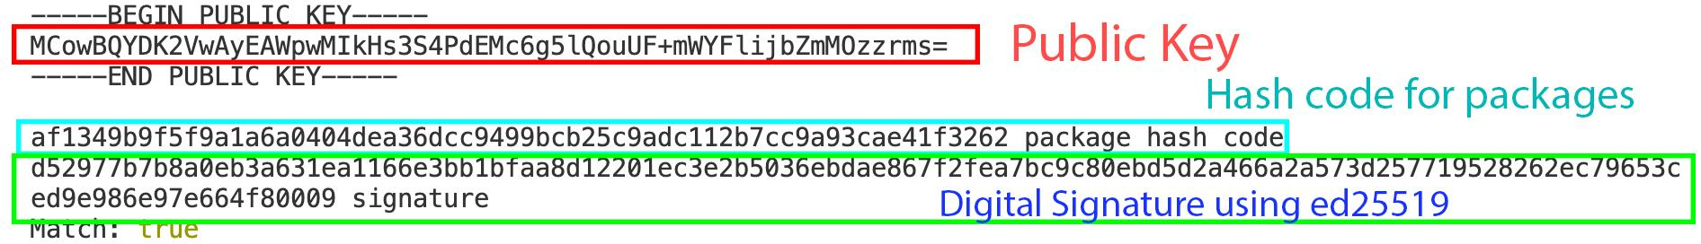

Note the public key, hash code , digital signature in the console which will be used to update in 3.2.4.

3.2.4 Updating XT-Package-Config.json (after packages hashing)

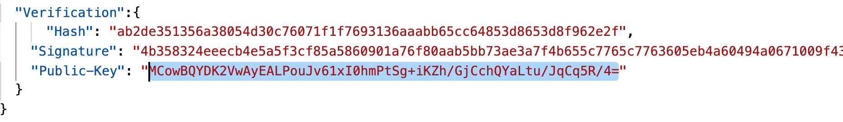

Hash: Hash code for the packages we generated in previous Step 3.1.4
Signature: Digital Signature for the packages we generated in previous Step 3.1.4
Public-Key:Public key for the packages we generated in previous Step 3.1.4

